7a. The Impact of Enlightenment in Europe
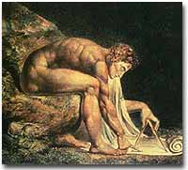
Blake's representation of Newton.
The AGE OF REASON, as it was called, was spreading rapidly across Europe. In the late 17th century, scientists like ISAAC NEWTON and writers like JOHN LOCKE were challenging the old order. Newton's laws of gravity and motion described the world in terms of natural laws beyond any spiritual force. In the wake of political turmoil in England, Locke asserted the right of a people to change a government that did not protect natural rights of life, liberty and property. People were beginning to doubt the existence of a God who could predestine human beings to eternal damnation and empower a tyrant for a king. Europe would be forever changed by these ideas.
In America, intellectuals were reading these ideas as well. On their side of the Atlantic, Enlightened ideas of liberty and progress had a chance to flourish without the shackles of Old Europe. Religious leaders began to change their old dogmatic positions. They began to emphasize the similarities between the Anglican Church and the Puritan Congregationalists rather than the differences. Even COTTON MATHER, the Massachusetts minister who wrote and spoke so convincingly about the existence of witches advocated science to immunize citizens against smallpox. Harvard ministers became so liberal that YALE COLLEGE was founded in New Haven in 1707 in an attempt to retain old Calvinist ideas. This attempt failed and the entire faculty except one converted to the Church of England in 1722. By the end of the century, many New England ministers would become UNITARIANS, doubting even the divinity of Christ.
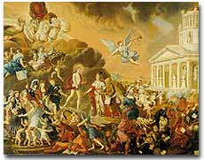
Painting by Duplessis Triomphe de Voltaire
New ideas shaped political attitudes as well. John Locke defended the displacement of a monarch who would not protect the lives, liberties, and property of the English people. JEAN-JACQUES ROUSSEAU stated that society should be ruled by the "general will" of the people. BARON DE MONTESQUIEU declared that power should not be concentrated in the hands of any one individual. He recommended separating power among executive, legislative, judicial branches of government. American intellectuals began to absorb these ideas. The delegates who declared independence from Britain used many of these arguments. The entire opening of the Declaration of Independence is Thomas Jefferson's application of John Locke's ideas. The constitutions of our first states and the UNITED STATES CONSTITUTION reflect Enlightenment principles. The writings of Benjamin Franklin made many Enlightenment ideas accessible to the general public.
The old way of life was represented by superstition, an angry God, and absolute submission to authority. The thinkers of the Age of Reason ushered in a new way of thinking. This new way championed the accomplishments of humankind. Individuals did not have to accept despair. Science and reason could bring happiness and progress. Kings did not rule by divine right. They had an obligation to their subjects. Europeans pondered the implications for nearly a century. Americans put them into practice first.

7b. The Great Awakening
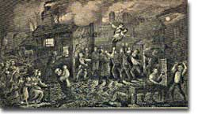
At age six, John Wesley was rescued from a burning room in his father's rectory, depicted here in this 19th century engraving. The dramatic incident caused him to refer to himself later in life as a "brand plucked from the burning."
Not all American ministers were swept up by the Age of Reason. In the 1730s, a religious revival swept through the British American colonies. JONATHAN EDWARDS, the Yale minister who refused to convert to the Church of England, became concerned that New Englanders were becoming far too concerned with worldly matters. It seemed to him that people found the pursuit of wealth to be more important than John Calvin's religious principles. Some were even beginning to suggest that predestination was wrong and that good works might save a soul. Edwards barked out from the pulpit against these notions. "God was an angry judge, and humans were sinners!" he declared. He spoke with such fury and conviction that people flocked to listen. This sparked what became known as the GREAT AWAKENING in the American colonies.
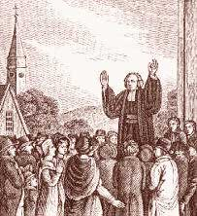
Portraits of Faith George Whitefield
GEORGE WHITEFIELD was a minister from Britain who toured the American colonies. An actor by training, he would shout the word of God, weep with sorrow, and tremble with passion as he delivered his sermons. Colonists flocked by the thousands to hear him speak. He converted slaves and even a few Native Americans. Even religious skeptic Benjamin Franklin emptied his coin purse after hearing him speak in Philadelphia.
Soon much of America became divided. Awakening, or NEW LIGHT, preachers set up their own schools and churches throughout the colonies. PRINCETON UNIVERSITY was one such school. The OLD LIGHT ministers refused to accept this new style of worship. Despite the conflict, one surprising result was greater religious toleration. With so many new denominations, it was clear that no one religion would dominate any region.
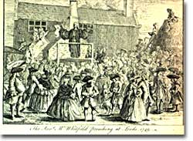
The dramatic George Whitefield preaching in the open-air at Leeds in 1749.
Although the Great Awakening was a reaction against the Enlightenment, it was also a long term cause of the Revolution. Before, ministers represented an upper class of sorts. Awakening ministers were not always ordained, breaking down respect for betters. The new faiths that emerged were much more democratic in their approach. The overall message was one of greater equality. The Great Awakening was also a "national" occurrence. It was the first major event that all the colonies could share, helping to break down differences between them. There was no such episode in England, further highlighting variances between Americans and their cousins across the sea. Indeed this religious upheaval had marked political consequences.

7c. The Trial of John Peter Zenger
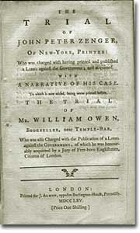
John Peter Zenger became a symbol for the freedom of the press in the young American colonies. Seen above is a printing of the trial proceedings.
No democracy has existed in the modern world without the existence of a FREE PRESS. Newspapers and pamphlets allow for the exchange of ideas and for the voicing of dissent. When a corrupt government holds power, the press becomes a critical weapon. It organizes opposition and can help revolutionary ideas spread. The trial of JOHN PETER ZENGER, a New York printer, was an important step toward this most precious freedom for American colonists.
John Peter Zenger was a German immigrant who printed a publication called The NEW YORK WEEKLY JOURNAL. This publication harshly pointed out the actions of the corrupt royal governor, WILLIAM S. COSBY. It accused the government of rigging elections and allowing the French enemy to explore New York harbor. It accused the governor of an assortment of crimes and basically labeled him an idiot. Although Zenger merely printed the articles, he was hauled into jail. The authors were anonymous, and Zenger would not name them.
In 1733, Zenger was accused of LIBEL, a legal term whose meaning is quite different for us today than it was for him. In his day it was libel when you published information that was opposed to the government. Truth or falsity were irrelevant. He never denied printing the pieces. The judge therefore felt that the verdict was never in question. Something very surprising happened, however.
The first jury was packed with individuals on Cosby's payroll. Throughout this process, Zenger's wife Anna kept the presses rolling. Her reports resulted in replacing Cosby's jury with a true jury of Zenger's peers.
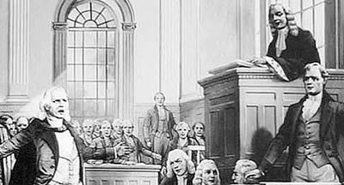
When the trial began and Zenger's new attorney began his defense, a stir fluttered through the courtroom. The most famous lawyer in the colonies, ANDREW HAMILTON of Philadelphia, stepped up to defend Zenger. Hamilton admitted that Zenger printed the charges and demanded the prosecution to prove them false. In a stirring appeal to the jury, Hamilton pleaded for his new client's release. "It is not the cause of one poor printer," he claimed, "but the cause of liberty." The judge ordered the jury to convict Zenger if they believed he printed the stories. But the jury returned in less than ten minutes with a verdict of not guilty.
Cheers filled the courtroom and soon spread throughout the countryside. Zenger and Hamilton were hailed as heroes. Another building block of liberty was in place. Although true freedom of the press was not known until the passage of the FIRST AMENDMENT, newspaper publishers felt freer to print their honest views. As the American Revolution approached, this freedom would become ever more vital.

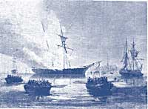
7d. Smuggling
Artist unkown Rhode Island Colonists led by John Brown burn the British revenue cutter Gaspee
The British had an empire to run. The prevailing economic philosophy of seventeenth and eighteenth century empires was called MERCANTILISM. In this system, the colonies existed to enrich the mother country. Restrictions were placed on what the colonies could manufacture, whose ships they could use, and most importantly, with whom they could trade. British merchants wanted American colonists to buy British goods, not French, Spanish, or Dutch products. In theory, Americans would pay DUTIES on imported goods to discourage this practice. The NAVIGATION ACTS and the MOLASSES ACT are examples of royal attempts to restrict colonial trade. SMUGGLING is the way the colonists ignored these restrictions.
Distance and the size of the British Empire worked to colonial advantage. Prior to 1763, the British followed a policy known as SALUTARY NEGLECT. They passed laws regulating colonial trade, but they knew they could not easily enforce them. It cost four times as much to use the British navy to collect duties as the value of the duties themselves. Colonists, particularly in New England, thought nothing of ignoring these laws. Ships from the colonies often loaded their holds with illegal goods from the French, Dutch, and Spanish West Indies. British customs officials earned a modest salary from the Crown. They soon found their pockets stuffed with bribe money from colonial shippers. When smugglers were caught, they were often freed by sympathetic American juries. Smuggling became commonplace. The British estimated that over £700,000 per year were brought into the American colonies illegally.
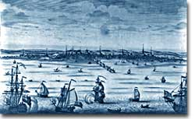
Boston Harbor, circa 1746, was home to a successful colonial merchant fleet.
As 1776 approached, the tradition of smuggling became vital to the Revolutionary cause. This encouraged ignoring British law, particularly in the harbors of New England. American shippers soon became quite skilled at avoiding the British navy, a practice they used extensively in the Revolutionary War. Soon England began to try offenders in admiralty courts, which had no juries. All attempts to crack down merely brought further rebellion. Woe to the parent who attempts to contain the child who has been allowed to roam free.

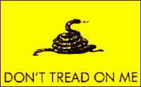
7e. A Tradition of Rebellion
The Gadsden Flag was an early American flag that originated in South Carolina before the Revolution.
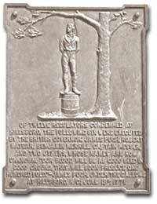
The American colonies had known violent rebellion long before the Revolutionary War. Each of the original thirteen colonies had experienced violent uprisings. Americans had shown themselves more than willing to take up arms to defend a cause held dear. This tradition of rebellion characterized the American spirit throughout its early history.

Bacon's Rebellion
One of the earliest large-scale insurrections was BACON'S REBELLION. In 1676, NATHANIEL BACON led a group of disgruntled citizens from the western part of Virginia eastward in search of justice. They felt their interests were not represented by Virginia's colonial legislature. They felt GOVERNOR BERKELEY had done nothing to protect them from Indian raids. These frontier Virginians felt excluded from the riches of the eastern seaboard.
Over a thousand of Bacon's followers entered Jamestown and burned the capital city. Governor Berkeley fled until reinforcements could organize. The rebels pillaged and plundered the countryside until Berkeley's forces crushed them. Over twenty rebels were hanged, but fear of further rebellion was struck into the hearts of the members of the wealthy Virginia planting class.

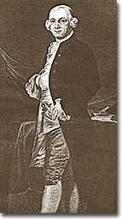
Regulators or Traitors?
Similar uprisings took place all along the colonial backwoods. In South Carolina a rebellion broke out as a result of the Regulator movement. There was anarchy on the South Carolina frontier after the Seven Years' War.
From 1765 to 1767 outlaws roamed the landscape holding local farmers at their mercy. A band of vigilantes known as REGULATORS took the law into their own hands and pushed the outlaws away. The Regulators then turned their wrath on local hunters who raised a force to fight back. Near civil war conditions prevailed until the government finally agreed to institute a circuit court judicial system. A similar movement broke out in North Carolina the following decade.
Land riots took place in many colonies, but in New York they were particularly violent. Tenants of the wealthy land aristocrats demanded relief from the high rents imposed on them. When the courts ruled in favor of the land barons in 1766, the angry farmers took up arms. The governor had to bring in the Redcoats to quell the disturbance.
In Pennsylvania, a group of Scots-Irish settlers called the PAXTON BOYS marched on Philadelphia in 1764 to protest the Quakers' friendly Native American policy. The Paxtons lived in Pennsylvania's hinterland and wanted both Native American land and protection from raids on their homes. A delegation, led by Benjamin Franklin met with the Paxton gang to hear their grievances. Order was restored — but just barely before the Paxtons would have attacked Philadelphia.
American colonists had proven themselves experienced rebels. Whenever they felt their rights were jeopardized, they seemed willing to take up arms. Economic exploitation, lack of political representation, unfair taxation, were among the causes that led to these clashes.
Reverberations from the rebellions reached England from 1763 to 1776. Parliament and the monarchy heard this Colonial message loud and clear: "DON'T TREAD ON ME."

7f. "What Is the American?"
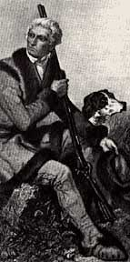
Adventurous men of diverse ethnic backgrounds who pushed the western boundaries of the colonies, created uniquely American roles. One such role is the Frontiersman, exemplified by Daniel Boone.

MICHEL-GUILLAUME DE CRÈVECOEUR was a French settler in the American colonies in the 1770s. Coming from France he could not believe the incredible diversity in the American colonies. Living in one area, he encountered people of English, Welsh, Scots-Irish, German, French, Irish, Swedish, Native American, and African descent. "What then is the American, this new man?" He could not be sure, but he knew it to be different from anything that could be found on the European side of the Atlantic.

At the time of the American Revolution, English citizens made up less than two thirds of the colonial population, excluding Native Americans. Nearly one fifth of the population was of African descent. Of the white population, there was still tremendous diversity, particularly in Pennsylvania, America's first MELTING POT. Most numerous of the non-English settler population were the Germans and the Scots-Irish.

Germans came to Pennsylvania at the turn of the 18th century in answer to advertisements in Germany placed by William Penn. The promise of religious freedom, economic opportunity and freedom from war accelerated the arrival of Germans in the 1700s. English-speaking Americans misinterpreted the word Deutsch — the German word for German — and the settlers became consequently known as the PENNSYLVANIA DUTCH. Along with linguistic and cultural diversity, the Germans brought new religions to America, the most prominent of which was Lutheranism.

The SCOTS-IRISH were twice displaced. They originated in the Scottish Lowlands, but fled to Ireland to escape poverty. They found little prosperity there, as well. In addition, the Catholic Irish had little desire to share their island with the Presbyterian Scots, so they migrated to America. Much of the best farmland had already been claimed, so many Scots-Irish moved into APPALACHIA. Here they frequently fought with the Indians and resented being controlled by wealthy planters and politicians — reminding them of what they had left behind.

Soon these cultures began to blend. Americans became culturally distinct from the English. Their language, culture, and religions differed greatly from those of MOTHER ENGLAND. Most Americans were born here and never even visited England during their lives. The Germans were never loyal to England. The Scots-Irish had great resentment toward Great Britain. The ties that bound them to the British Crown were weakening fast.

